1



**Safety Data Viewer User Guide**

Table of Contents

Introduction. 3

Overview 3

Work Flow 4

Map Selection. 5

Selecting from Map. 5

Additional Geography details. 7

Selecting from SIP Portal. 8

Before / After - Additional Step. 8

Analysis Details. 9

Crash History 9

Before / After 11

Advanced Query 14

Summary 17

Explore / Filter Export. 18

Additional Functionality 19

Add-Ons. 19

Location Search. 21

Data Context. 22

CLION. 22

NYSDOT 22

Fatality 23

NYPD. 23

Ranking. 24

# Introduction

## Overview

The Traffic Safety Data Viewer (SDV) is an internal web application designed to provide access to the traffic crash data and standard analyses used for project development and post implementation analysis. The SDV application is the primary source for crash data and analysis for most location specific inquiries. The application utilizes three dif- ferent crash data sets, depending on the analysis being performed. The NYSDOT SIMS data is used for most analyses, the NYCDOT-NYPD fatality data is used for all fatalities, and the NYPD FORMS/TAMS data is used for the most up-to-date crash trends.



There are four primary functions



in the application:

The standard 5 year “crash history” for a study area, generates the corridor traffic safety

report. This report is used in project exploration, design, and prioritization. The crash history is always the 5 years of NYSDOT (and NYCDOT fatalities), and defaults to the latest 5 years. The injuries are displayed on the map and aggregated by intersection and midblock center point. The report provides the ranking (corridor projects only) of how dangerous the study area is compared to all other corridors in the borough.

The “before-after” analysis is intended as a standardized method of analyzing the safety performance of a project after it has been implemented. This function uses the NYPD data to allow for the most recent data available to be used. The structure of a standard before / after analysis is to compare the 3 years prior to construction to the annualized crashes for 1, 2, or 3 years after construction, depending on how much time has passed since the end of con- struction.

The “advanced query” function is useful for data exploration and allows either NYPD or NYS- DOT data. The NYPD data includes data up to the current date. The excel output includes ad- ditional details from each crash when it is available. The NYSDOT data allows for user defined cross-tab tables. The cells reflect the total number of injuries that meet the criteria in both the row and columns the user defined. The export excel feature functions the same way as in the crash history function.



The “summary stats” function provides basic injury stats (NYSDOT/NYCDOT fatalities) by political / administrative district for a 5 year period. The map will display the relative rank of

the districts by injuries per square mile for the 5 year period compared to the other districts in

the city.

## Work Flow

The typical workflow would be for the user to select the location they are interested in, then choose the type of analysis and define any parameters. The location selection can be selected directly from the map or by importing a project from the SIP Portal.

The map-based selection allows a user to select intersections or segments depend- ing on the study area. SIPs can be found by using the SIP Portal ID (pid) or by search- ing for the SIP by various attributes. Once the study area and analysis are returned, the user can select various subsets of the data via the table(s) to see if there are any concentrations within a study area.

### Select the Location or SIP Search

1



### Identify Analysis Type

2

 Crash History 

Advanced Queries

Before After Summary Stats

### Filter/Download Outputs

3



# Map Selection

The SDV application uses selections from the street network to filter the crashes included in analyses. There are 2 ways of defining a study area in the SDV application:

* Selecting directly in the application
* Importing from the SIP portal application.

## Selecting from Map

To select a location from the map, the user must select corridor or intersection from the menu on the left side. This will define what is being selected from the map.



Then click the button on the top right of the map to begin selecting.

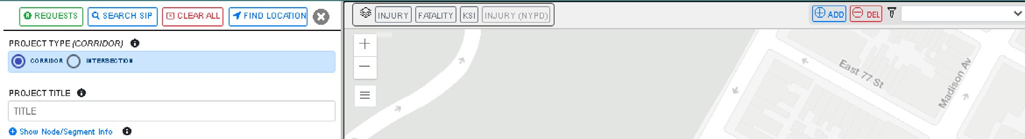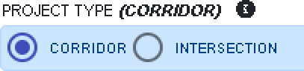

To select [the study area] the user clicks and drags a rectangle over the streets/ intersections to be analyzed. Because the application uses CLION if any portion of a block/intersection is selected all segments/nodes of the block/intersection will be added to the selection (see CLION section for further explanation).

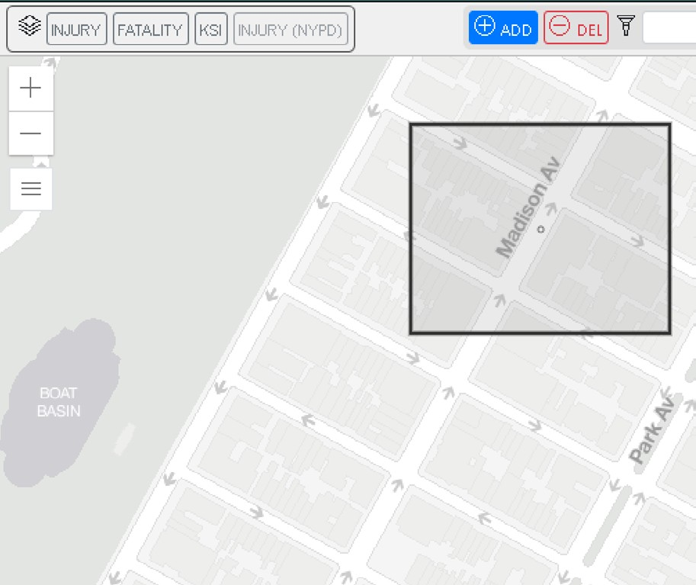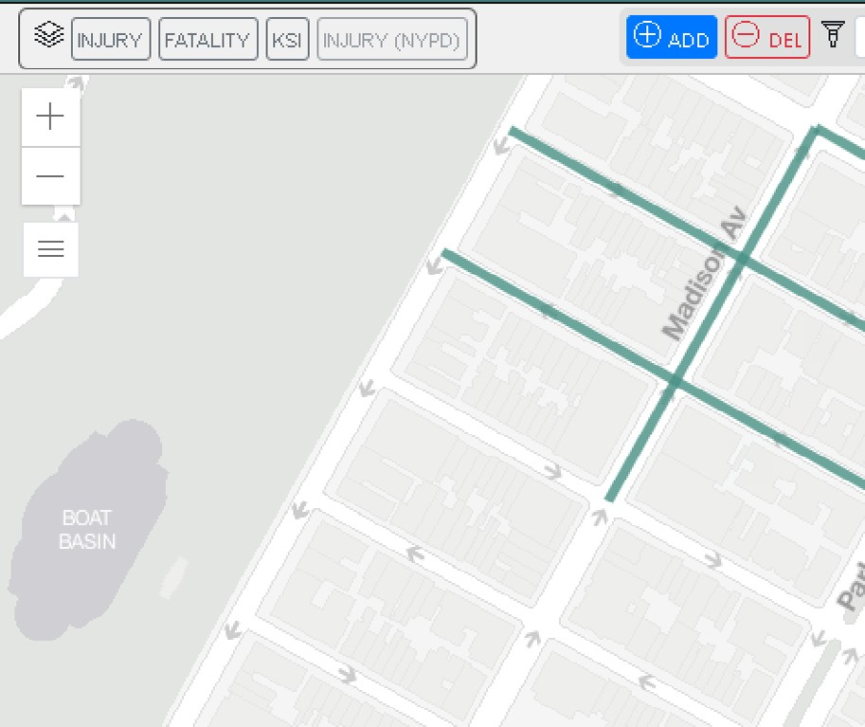

To continue adding additional segments/nodes to the selection simply repeat the prior step. If selecting a corridor, once an initial selection is made the user can choose a street name to limit all future additions to that street. This is helpful when selecting long corridors.

Adding additonal segments limited to one street name

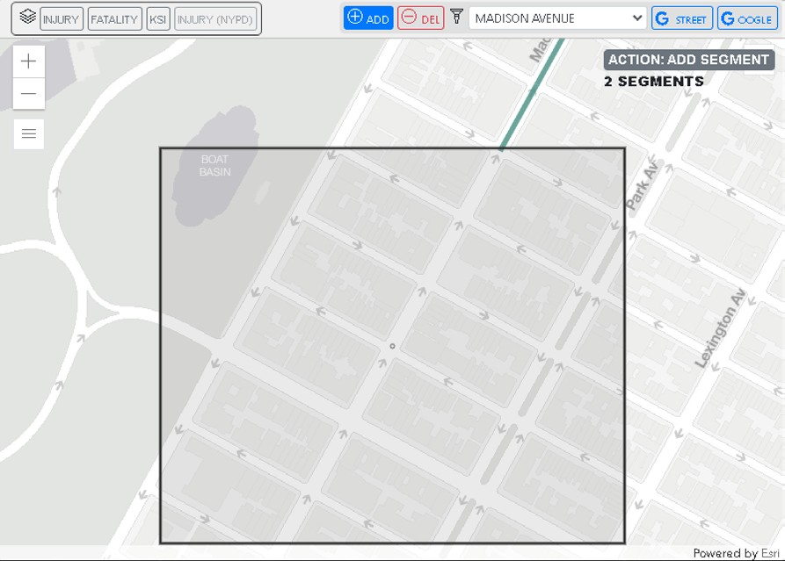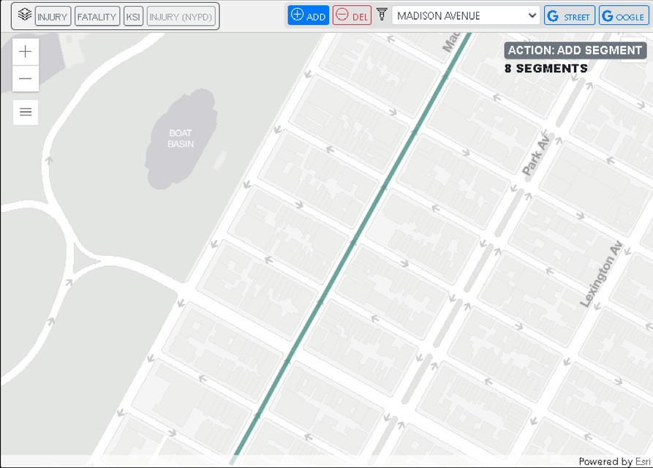

## Additional Geography details

To remove segments/nodes from a selection use the  button. Using the street name filter here will remove any segments in the user defined rectangle except the streets with the filter name.

Any selections on a street with a divided roadbed will show up as centerline selec- tion once the crash analysis is run. This does not impact the selection, but is for display purposes. All of the segments or nodes that are used in the analysis are provided in the Show Node/Segment info section (hidden by default).

Divided Roadbed

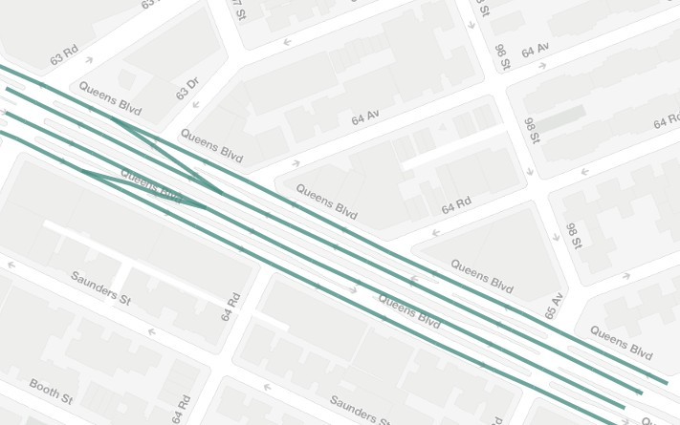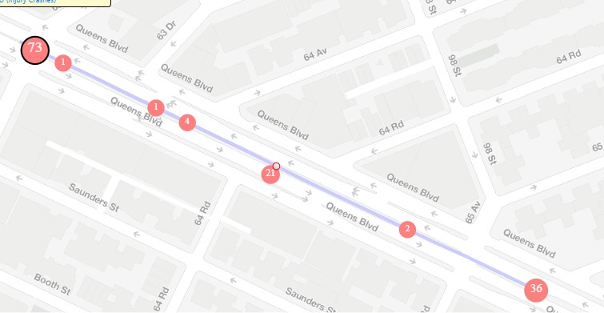

Centerline

## Selecting from SIP Portal

in



To utilize the geometry from an existing (or planned) project that was already defined the SIP portal, use the [sip search] button at the top of the menu on the left side. The

user can select the project geometry by entering the SIP ID number or by searching by project attributes.

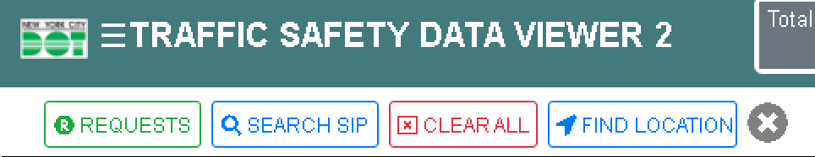

*Note: This button is not visible if the user does not have permissions to access the SIP portal.*

Sip Project: Broadway, 2016

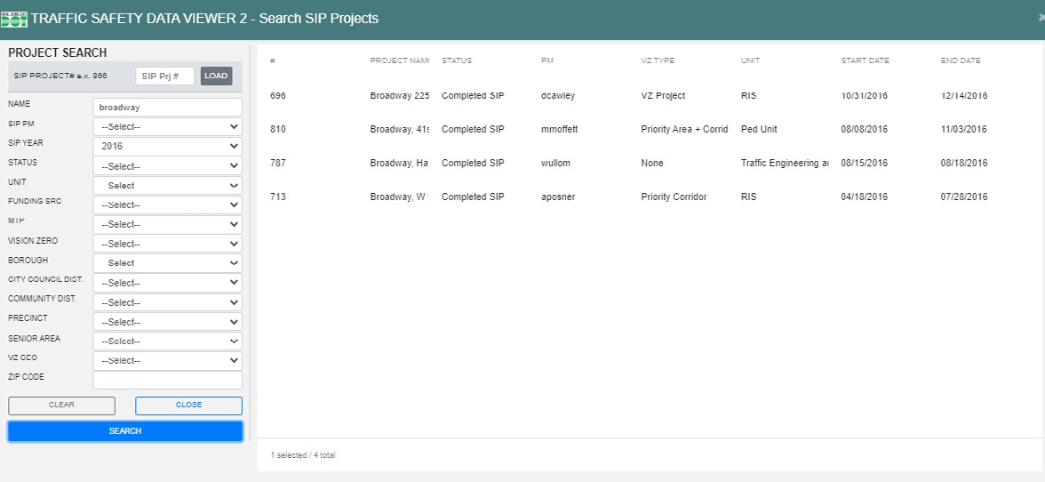

## Before / After - Additional Step

Because the **NYPD data is intersection only**, any locations defined by a selected cor- ridor need to be translated into nodes. When corridors are used for the input geometry (either from importing a SIP project or selecting from the map) an extra step is needed. In these cases the user is presented with a confirmation page, which includes the input segments and the resulting selected nodes. In the cases where the segment to node translation yields unexpected results, then the user can use the button to correct this over selection, the original segment selection is shown in blue as a guideline.

More information here —>

# Analysis Details

## Crash History

The standard 5 year crash history for a study area, generates the corridor traffic safety report. This report is used in project exploration, design, and prioritization. The crash history is always the 5 years of NYSDOT (and NYCDOT fatalities), defaults to the latest 5 years. The injuries are displayed on the map and aggregated by intersection and mid- block center point.

The report provides the ranking (corridor projects only) of the how dangerous study area is compared to all other corridors in the borough. If the study area crosses bor- ough boundaries the borough with the majority of the project’s mileage is used as the reference. The thresholds for the different ranks in each borough for the given years is provided in the Rank Class info section (hidden by default). The ranking is intended to provide some context to the numbers. The ranking is based on the total number of peo- ple Killed or Severely Injured (KSI) per mile in the study area.

The crash history function provides the following statistics, in 5-year ranges:

* Injury summary (injuries by mode and severity)
* Fatalities (5 year analysis period and through the present)
* Non-fatal injuries by severity
* Injuries by year
* Injuries by time of day by type
* Pedestrian injuries by intersection control and pedestrian action
* Bicycle injuries by intersection control and bicyclist action
* Motor vehicle injuries by collision type
* Injuries by age group
* Pedestrian injuries by vehicle action and pedestrian action

All tables are interactive, meaning each cell in any table acts as a filter for the crashes displayed on the map. For example the 1st table is the injury severity by mode, so selecting the upper left most cell would limit the crashes on the map to pedestrian KSI.

Unfiletered Crashes Filtered By Severe Injuries

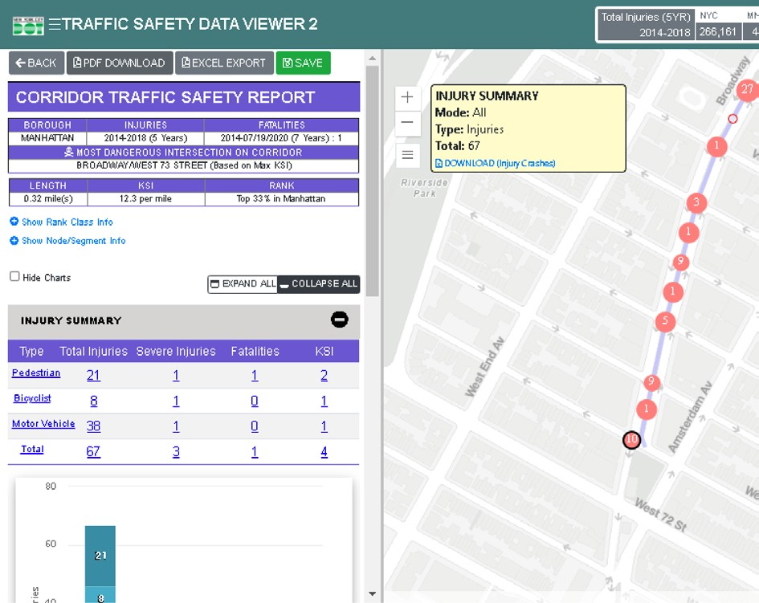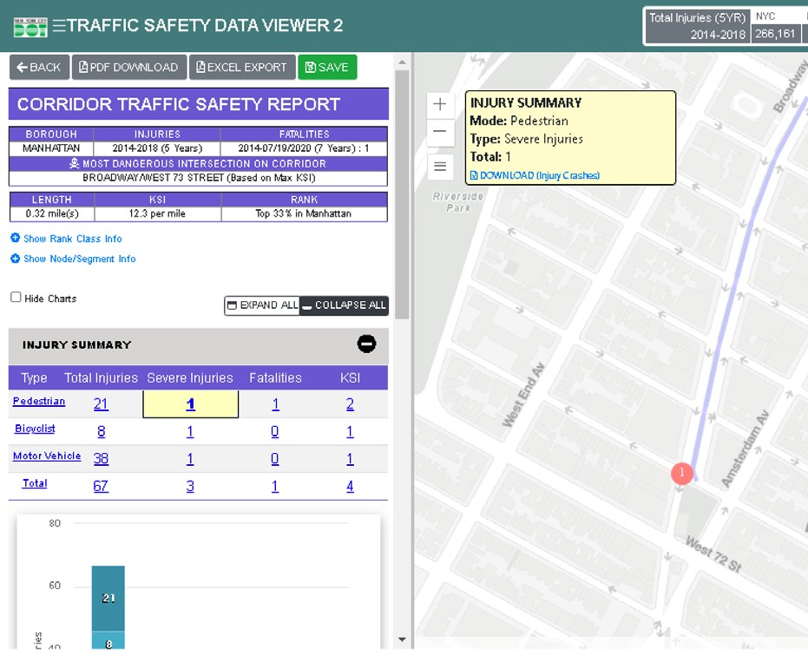

The fatalities used are always from the NYCDOT-NYPD reconciled fatality data and 2 slices of the data are provided in the second table. **The fatalities for the 5 years in- cluded in the analysis and the total fatalities from the beginning of the analysis period to present (typically a day or two lag).** This second number is not intended for analysis, but to keep the user informed of any recent fatalities in the study area.

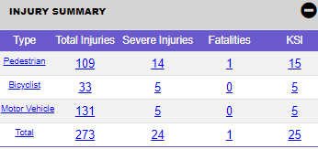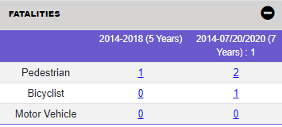

 **Before / After**

The before after analysis is intended as a standardized method of analyzing the safety performance of a project after it has been implemented. This function uses the NYPD data to allow for the most recent data available to be used. The NYPD data is available up through the end of the latest full month. Because this uses the NYPD data, the de- tails are limited to the number of injuries by mode.

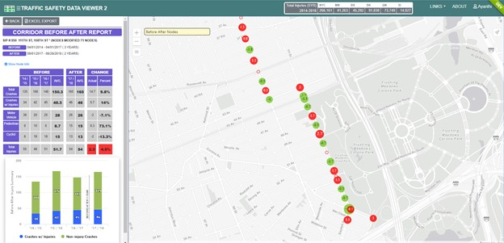

The structure of a standard before / after analysis is to compare the 3 years prior to con- struction to the annualized crashes for 1, 2, or 3 years after construction, depending on how much time has passed since the end of construction. Partial years are not included due to potential seasonal differences. The application will default to the maximum num- ber of full years after the end of construction (up to 3).

When a standard analysis is run the annualized injuries by mode table will show up in the application and the map will show the change in total injuries for each intersection in the analysis. Neither the table nor the map features are available for a sub-year analysis.



It is important to be aware that the NYPD switched to electronic crash report- ing in mid-2016. This change has a number of implications. The number of injuries jumped and have remained consistent since the change, the new data has additional info which can only be reliably reported for 2017 and later, the data now allows for rashes’ locations to be recorded with an address (poten- tially mid-block) as well as intersection (we force all crashes to intersections for consistency).

When a SIP is imported the project’s implementation dates are automatically entered into the before / after date fields, these can be altered if an adjustment period is needed.

Non-standard before/afters



If an analysis is needed before 12 months have passed since the end of construction a partial year analysis can be generated, but it does not include all tables. When less than 1 year of after data is available only months present in the after period will be included in the before period for consistency.

Advanced option is available for scenarios where non-standard conditions prevent the standard time frames for analysis. For example if an unrelated project that inter- sected the project geography was under construction during the 3rd before year the user may want to only include 2 years of before data in the analysis. The advanced query option allows the user to override the defaults for the start of the before period or the end of the after period.

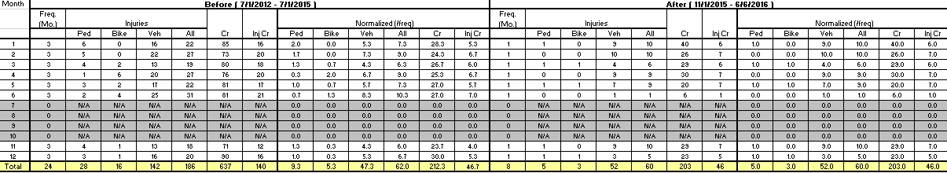

Selecting the study area

Because the NYPD data is intersection only, when selecting a location or importing a SIP for a before / after, if the selection or SIP is a corridor, an extra step is needed

user to

When segments are used for selection, a confirmation page is shown for the  confirm that the resulting selection of nodes derived from the originally selected seg-

ments is what is intended for analysis. In the cases where a segment is selected, but the segment is not meant to include the full block then the user can use the

button to correct the over selection of nodes, the original segment selection is shown in blue as a guideline. This behavior can occur in where segments, which are effec- tively entirely within an intersection, are included. Because the SDV works on blocks, the inclusion of these can yield unexpected results in the SDV.

Before/After Geometry Selection

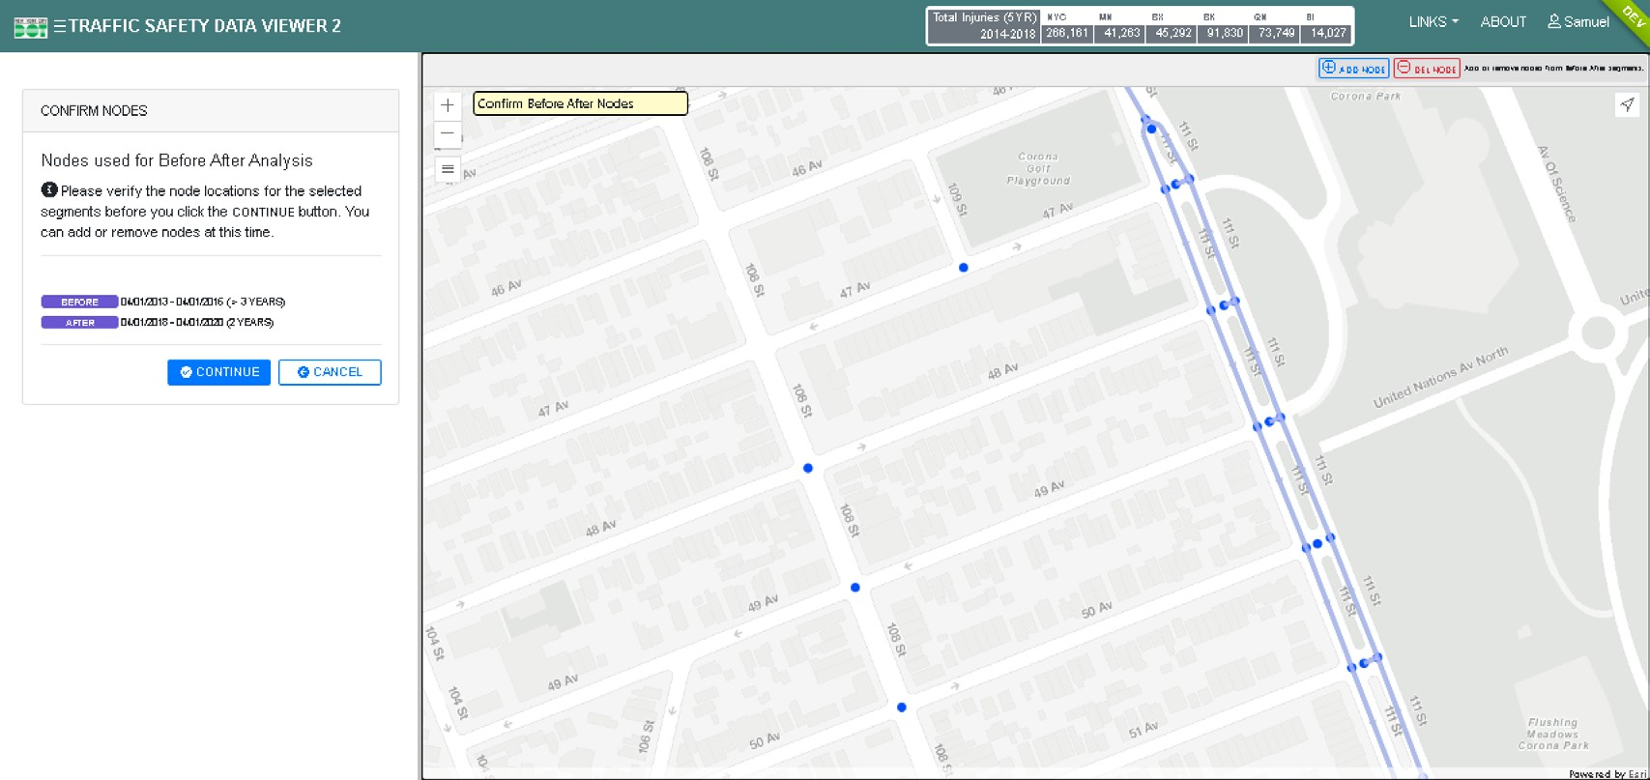

*In the image above, note that some intersections that don’t align with the SIP geometry are included. The circled nodes should not be included in the final node selection as they are not part of the project. The over selection should be corrected using the [del nodes] feature.*

i

## Advanced Query

The advanced query generates an injury by year summary [table] as well as several custom cross tabulations based on a variety of crash data variables. The advanced query allows for analyses for 2001 to the most recent year available. For the advanced query, you can choose to use NYPD or NYS crash data, but only the NYS data will generate the cross tabs.

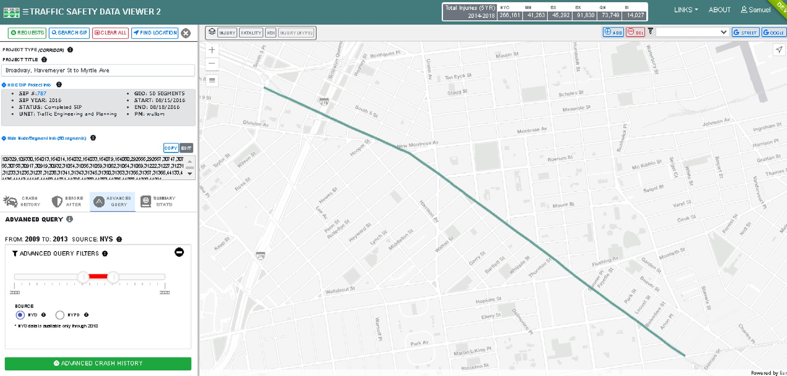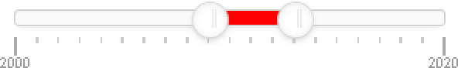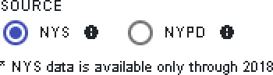

Select Year Range

Select data source

The custom cross-tab feature allows users to generate injury tables using different combinations of fields. Due to the structure of the NYSDOT data there are a num- ber of conditions which are ambiguous and therefore are counted as unknown or not applicable, depending on the fields involved in the cross tab. Each field has its own

restrictions and when two fields are used in this cross tab function the most restrictive conditions of both fields get applied to the whole table. For example, when pedes- trian action is crossed with motor vehicle action only pedestrian injuries (condition of pedestrian action) from crashes that involved only 1 motor vehicle (condition of motor vehicle action) are included.

Any crashes with bike or motor vehicle occupants would be in the NA category of the pedestrian action and any crashes with more than 1 motor vehicle would be in the unknown category of the motor vehicle action.

Crosstabs to create custom tables

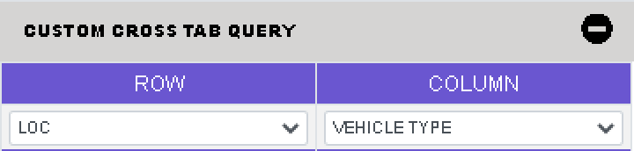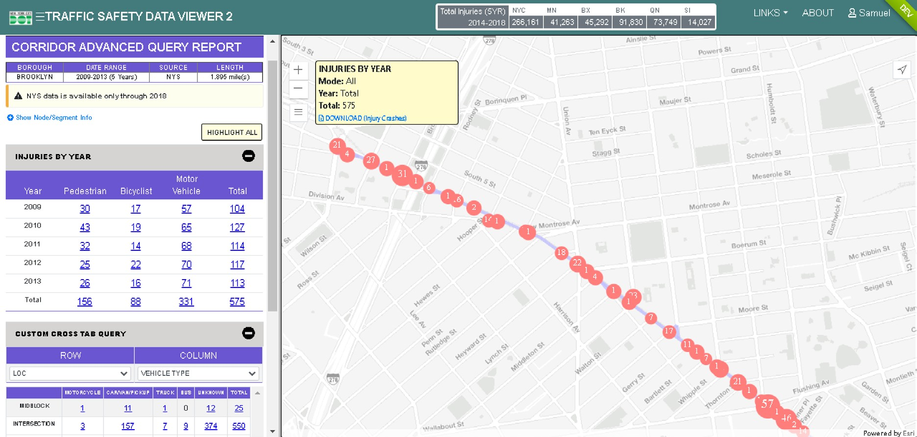

#### The variables that can be cross-tabbed with each other are:

* + **Year:** Year in which crash occurred.
  + **Time of Day:** Time at which crash occurred where time format is 24-hour clock and aggregated into 3-hour time periods.
  + **Traffic Control:** Type of traffic control at the location where the crash oc- curred as reported in the police report.
  + **Ped Action:** Action of pedestrian in crash where the motor vehicle involved collided with a pedestrian, limited to pedestrian crashes.
  + **Severity:** Severity of injuries for each victim involved in crash (limited to 5). The severity reported is defined by the NYS DMV KABCO score *
  + **Mode:** Mode of travel of injured victim involved in crash.
  + **Taxi/Livery:** True or False of whether or not crash involved at least one Taxi/ Livery.
  + **Vehicle Type:** The type of vehicle involved in crash where only 1 motor vehi- cle was involved. Crashes with more than 1 motor vehicle are considered unknown.
  + **MVO Pre Action:** Action of motor vehicle in crash where only 1 motor vehi- cle was involved. Crashes with more than 1 motor vehicle are considered unknown.
  + **Bike Pre Action:** Bike Action at time of Crash
  + **Age:** Age of injured victim involved in crash. Only reported for pedestrian and bicyclist injuries. The data structure prevents accurate reporting for motor vehicle occupant injuries.
  + **Sex:** Sex of injured victim involved in crash. Only reported for pedestrian and bicyclist injuries. The data structure prevents accurate reporting for motor vehicle occupant injuries.

*\* The KABCO scale for crash severity defines levels of injury severity.*

*“K” Fatal injuries include deaths which occur within thirty days following injury in a motor vehicle crash. This is not included, the SDV only uses fatalities from the NYCDOT / NYPD fatality database.*

*“A” Severe injuries include skull fractures, internal injuries, broken or distorted limbs, unconsciousness, severe lacerations, severe burns, and unable to leave the scene without assistance.*

*“B” Moderate injuries include visible injuries such as a “lump” on the head, abrasions, and minor lacerations. “C” Minor injuries include hysteria, nausea, momentary unconsciousness, and complaint of pain without visible signs of injury.*

*“Unk Severity” Severity of injury unknown*

*“O” No fatality or injury; property damage only This is not included as the advanced query includes the number of injuries in each category.*

[*\* https://www*](http://www.itsmr.org/tssr-glossary/kabco-scale/)*.itsmr*[*.org/tssr-glossary/kabco-scale/*](http://www.itsmr.org/tssr-glossary/kabco-scale/)

## Summary

The summary statistics panel provides a high level overview of crash statistics, aggregated to various geographic boundaries. Injury data is shown in fixed

5-year bins. The geographic boundaries you can aggregate crash data to are:

* Borough
* City council district
* Police precinct
* Neighborhood tabulation area
* State senate district
* State assembly district

The districts are ranked by total injuries per square mile and displayed on the map by quintile. Each district is clickable and when clicked will display the Injury Summary table for the district as a whole for the 5 years in the analysis period. The districts can be selected from the map or from the list in the. The 5 years to be used for the anal- ysis can be modified via the slider at the bottom of the panel on the left side of the application.

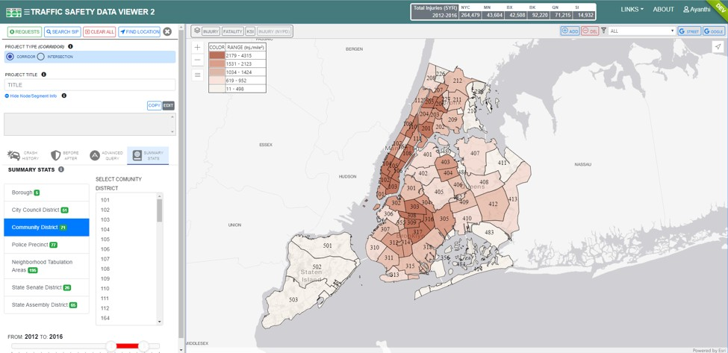

Summary Statistics page, showing a choropleth map of injuries in community districts.

## Explore / Filter Export

The generates a pdf version of the report with all of the table, and the map of the study area. The graphs are included in the pdf export of the report.

The  button will download a flattened version of the raw data for all crashes used in the analysis. The same flattened version of the data can be exported from the **download (injury crashes) link in the map which will only download the records shown in the map that meet the filter conditions (ie. if a cell in a table is se- lected).** The flattened table will include the 1st three vehicles and their contributing factors. Because the fatalities used are always from the NYCDOT-NYPD reconciled dataset and the data structure does not match with the NYSDOT data, the excel out- put only includes NYSDOT data.

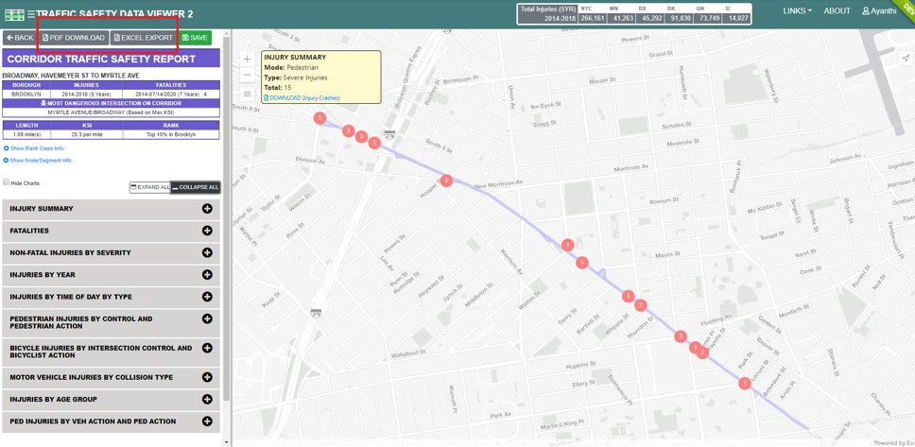

Additional Functionality

## Add-Ons

Display layers

At the top of the map there is a control for adding crash data to the display (largely for exploration purposes). The controls allow the user to display the NYSDOT inju- ry, the NYCDOT fatality, or the KSI data filtered by date and mode on the map. The numbers and size of the points is determined by the number of injuries and/or fatal- ities. The fatality layer, when clicked, also provides specific info about the case(s).

This includes a link to the Fatal Tracker app for the full case details; note this feature is limited to users with permission to access the Fatality Tracker.

Injury Layer

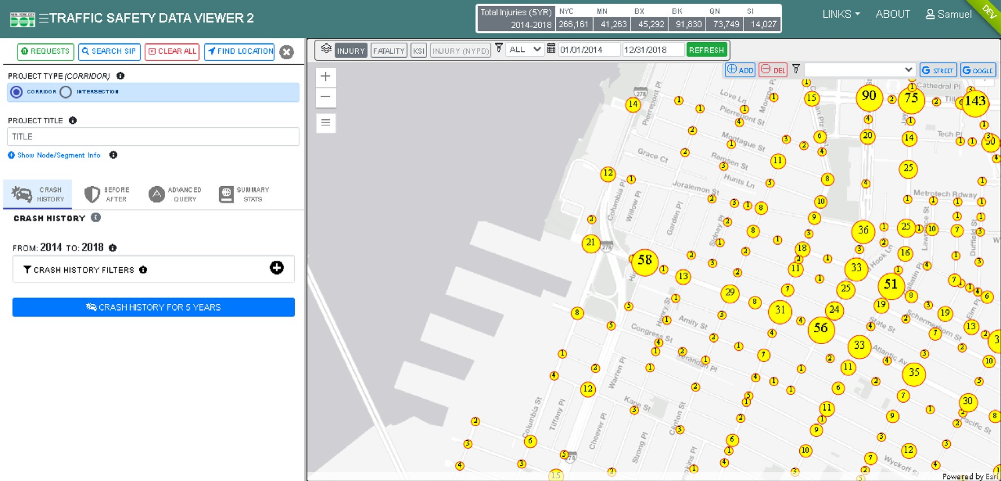

Select the injury type to show on the mape Select date range for injury display

#### 20

Auxiliary layers

There are a number of auxiliary display layers that are useful for reference. These are taken from the SIP portal and include political districts, Vision Zero and other priority areas. These are accessible via the hamburger button on the left side of the map. fatalities.

List of Filters:

* + Vision Zero Zones
  + Vision Zero Intersections
  + Vision Zero Corridors
  + Bike Lanes
  + Bike Priority Districts
  + Senior Areas
* City Council Districts
* Community Districts
* Zip Codes
* Police Precinct
* Boroughs
* CLion

Sample Filter – Community Districts

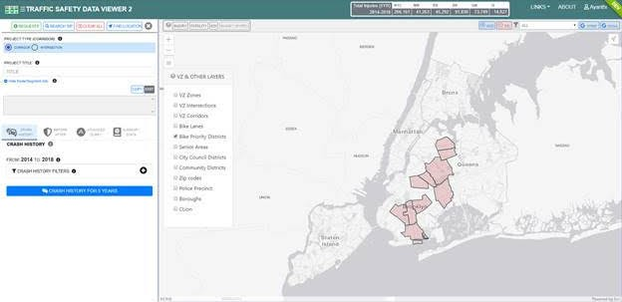

#### 21



## Location Search

An intersection search feature is available via the arrow button on the left side of the map or the find location at top right. The user can select the borough and then choose the on street and cross street from a list of valid intersecting streets.

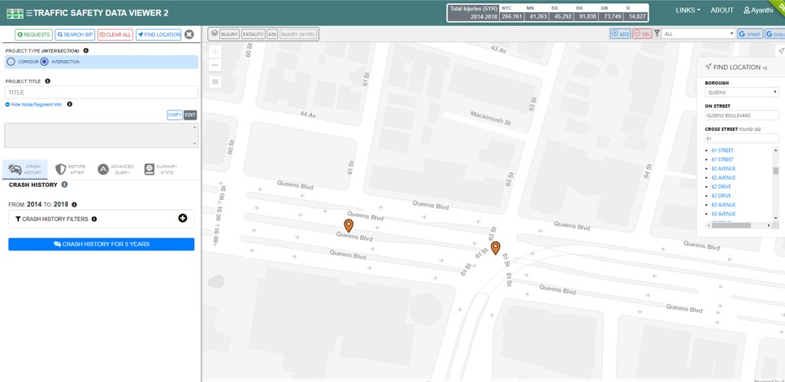

# Data Context

## CLION

CLION attempts to translate how people think about and talk about intersections and streets to how mapping software processes nodes and segments. CLION is an exten- sion to LION, which is a single line street base map representing the city’s streets and other linear geographic features such as shorelines, surface rail lines and boardwalks, along with feature names and address ranges for each addressable street segment.

Because the locations for the crashes are derived from the police reports which de- scribe the location, the most common pattern is ‘at the intersection of street 1 and street 2’. The problem with this is that there are often more than 1 intersections which match that description. In those cases we cannot determine which of the locations that match the description the crash happened at.

To account for this all intersections with matching street names will get a common Mas- terID. When the either of the locations is selected in the map, the application uses all of the locations with the MasterID to find the crashes. This condition is most commonly found at dog leg intersections and divided roadbed streets.

The CLION street network is updated annually with the latest “D” version of LION which coincides with the crash data update. Every year all crashes (and SIP projects and treat- ments) are re-mapped to the latest version of CLION. Because of this, crash data at the same location may vary when the same analysis is run in different years.

## NYSDOT

The NYSDOT data is the primary crash dataset used by NYCDOT. The data is provided to NYCODT annually by NYSDOT. The data is derived primarily from the crash reports filled out by NYPD. The crash reports are sent from NYPD to DMV, who enters the re- ports’ data into their database and calculates the injury severity. Individuals are also able to submit crash reports directly to DMV if there is no police report. The DMV data is sent to NYSDOT where it is reviewed for errors, mapped, and transformed into the NYSDOT schema. When NYCDOT receives the data from NYSDOT it is re-mapped to the CLION dataset and reviewed for errors an additional time. This process results in a 1-2 year time lag between the crash and when it is used by NYCDOT.

## Fatality

The fatality data comes from the NYCDOT-NYPD reconciled data, it is updated nightly from the Fatality Tracker application. This data is mapped to an older street network (Lion Tamed) and automatically remapped to CLION during the nightly transfer. This process is not 100% perfect and is a temporary solution while the Fatality Tracker is updated to utilize CLION. Because this data changes nightly it is possible that the same analysis run two days in a row can yield different results. New fatalities can be added and after investigation from NYPD some fatalities might be removed if they are deemed non-traffic related.

## NYPD

The NYPD data is updated nightly and typically has a 1-2 week lag. The data is entered by the police officers who respond to the crashes. The data does not undergo the same scrutiny and review process as the NYSDOT and fatality data, but offers the most cur- rent insight into crash trends in the city. The NYPD data comes from 2 data sources, the older TAMS database and the newer FORMS database.

TAMS

Prior to 2016 the NYPD crash data consisted of a very limited number of attributes and all crashes were reported at intersections. In the spring of 2016 NYPD began to adopt electronic reporting. The crash data for 2016 is a mix of the old system (TAMS) and the new system (FORMS). The SDV application uses the TAMS database for crashes be- tween 2000 and 2016, and the FORMS database for crashes between 2017 and pres- ent.

FORMS

The FORMS data includes all data entered on the police report for crashes. Because the SDV application needs to use both the FORMS and the TAMS database, the FORMS data is largely limited to the fields that were available in the TAMS data. In the excel out- put in the advanced query the accident description was added to all cases where it was available, which is limited to FORMS data.

## Ranking

The ranking system uses the KSI per mile of the selected corridor to the distribution of the KSI per mile of all other corridors in the same borough. If the selected corridor would be within the top 10% of the mileage of corridors in the same borough it is defined as a ‘high crash corridor’. All rankings are done on the same 5 years of data that is used for the study area’s crash history. Intersections are not ranked as there is no way to normal- ize (like corridor length) so the distribution of intersections by KSI does not yield mean- ingful results. It is important to note that this is not the same methodology that generat- ed the Vision Zero Priority corridors.

